Customer Shopping Behavior Analysis Report
Prepared by Sidd

1. Project Overview
This project focuses on analyzing customer shopping behavior using Python, PostgreSQL, SQL, and Power BI. The goal was to clean raw retail data, perform analytical queries, and build an interactive dashboard to generate business insights related to revenue, customer demographics, purchasing behavior, and product categories.

2. Objectives
- Clean and preprocess customer shopping data using Python and Pandas.
- Store structured data in PostgreSQL database.
- Perform SQL queries to extract business insights.
- Create an interactive Power BI dashboard for visualization.
- Identify trends related to customer purchases, categories, gender, and seasonal sales.

3. Tools & Technologies Used
- Python (Pandas, NumPy)
- Jupyter Notebook
- PostgreSQL
- SQL
- Power BI
- CSV Dataset

4. Dataset Summary
Total Records: 3,900
Total Columns: 18
Columns included customer demographics, product categories, purchase amounts, payment methods, review ratings, and subscription status.

5. Data Cleaning & Preprocessing
- Imported dataset using Pandas.
- Checked missing values and handled null entries.
- Created additional analytical columns for categorization.
- Performed datatype corrections and formatting.
- Prepared cleaned dataset for SQL and Power BI integration.

6. Python Data Cleaning Process
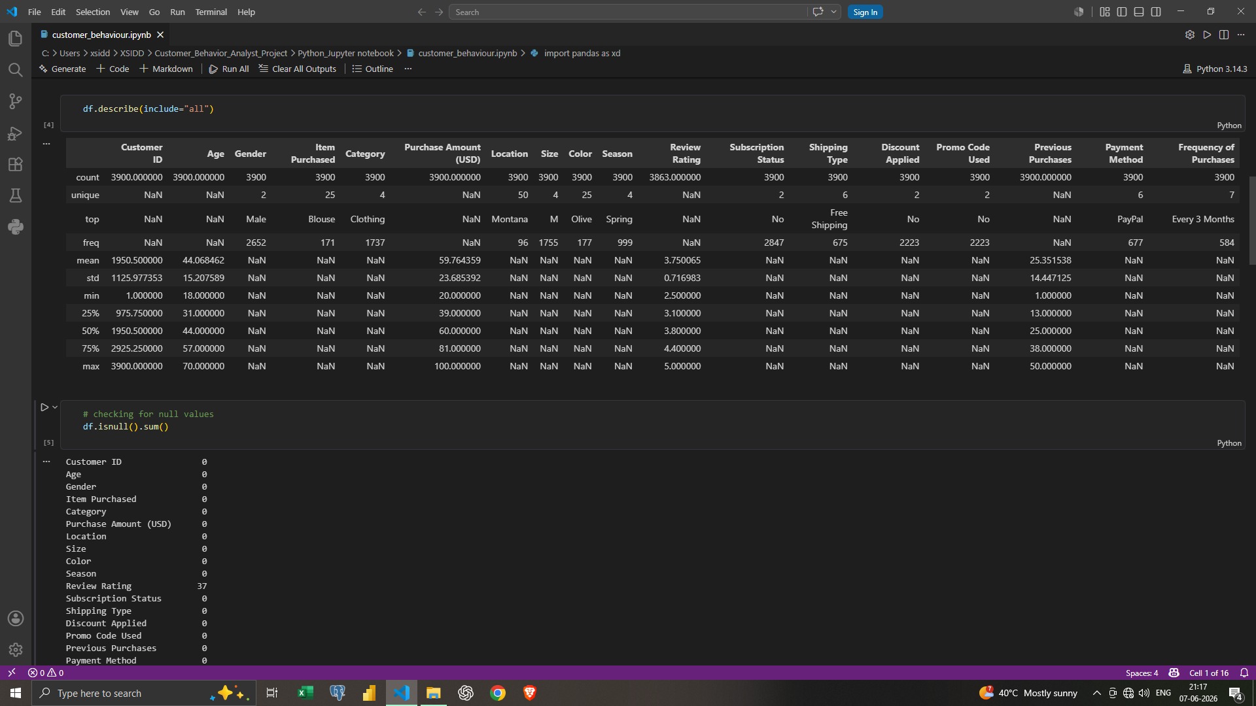
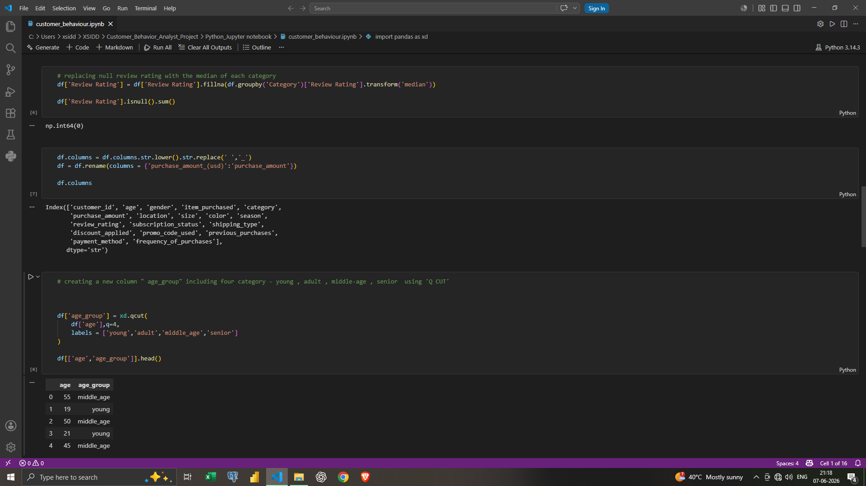
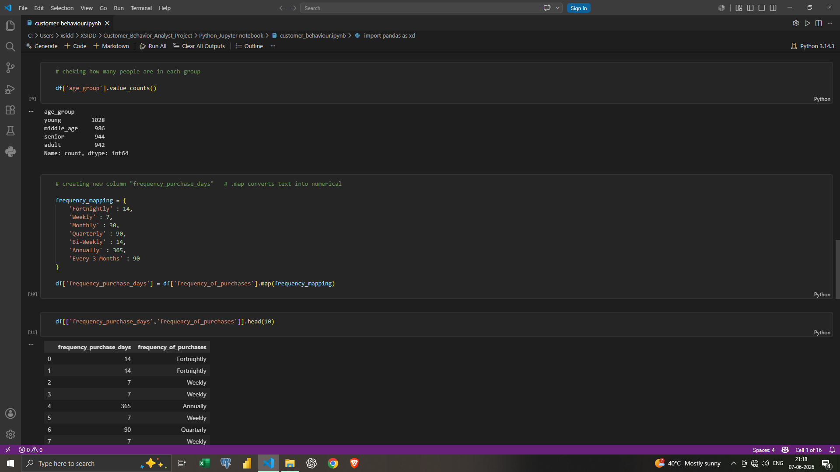
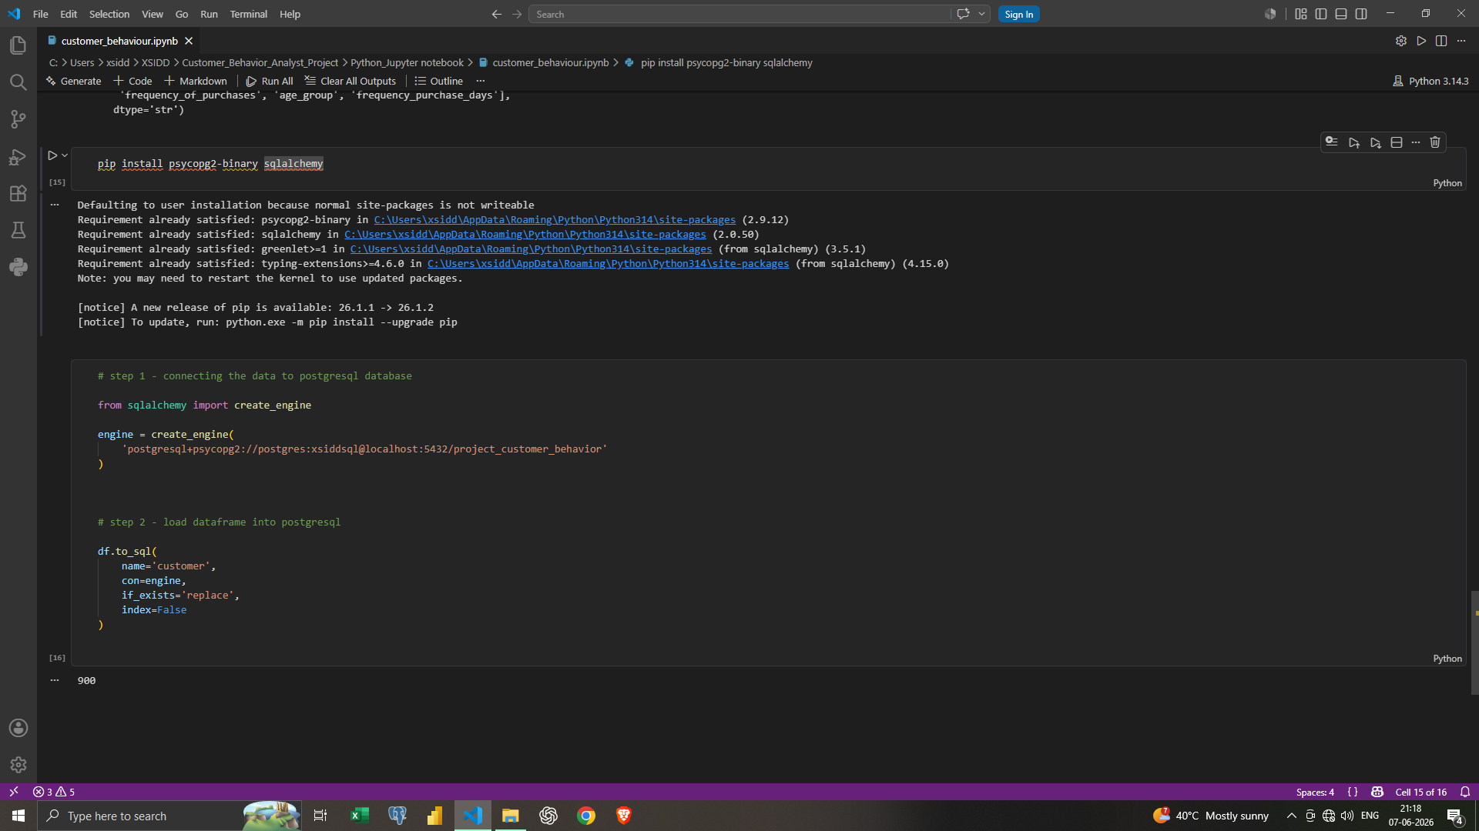
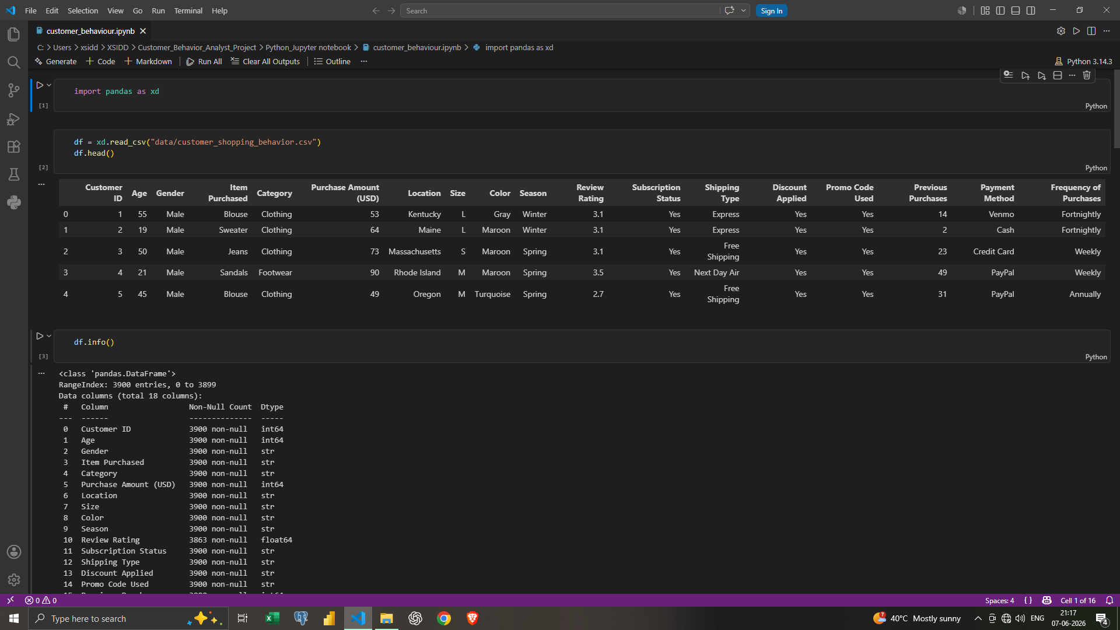

7. SQL Analysis
- Performed revenue analysis by gender and category.
- Identified top-performing product categories.
- Analyzed seasonal sales trends.
- Evaluated customer subscription behavior.
- Generated customer purchasing insights using SQL queries.
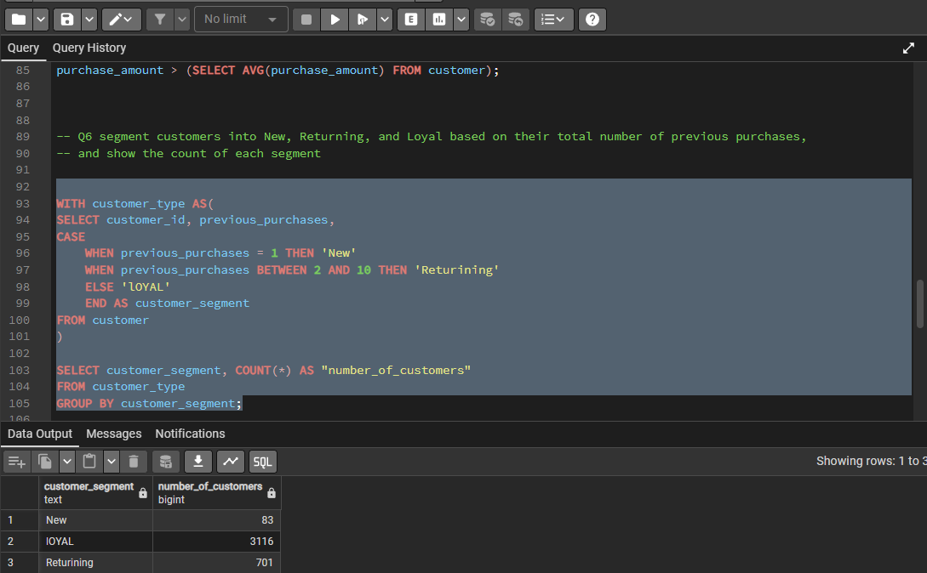
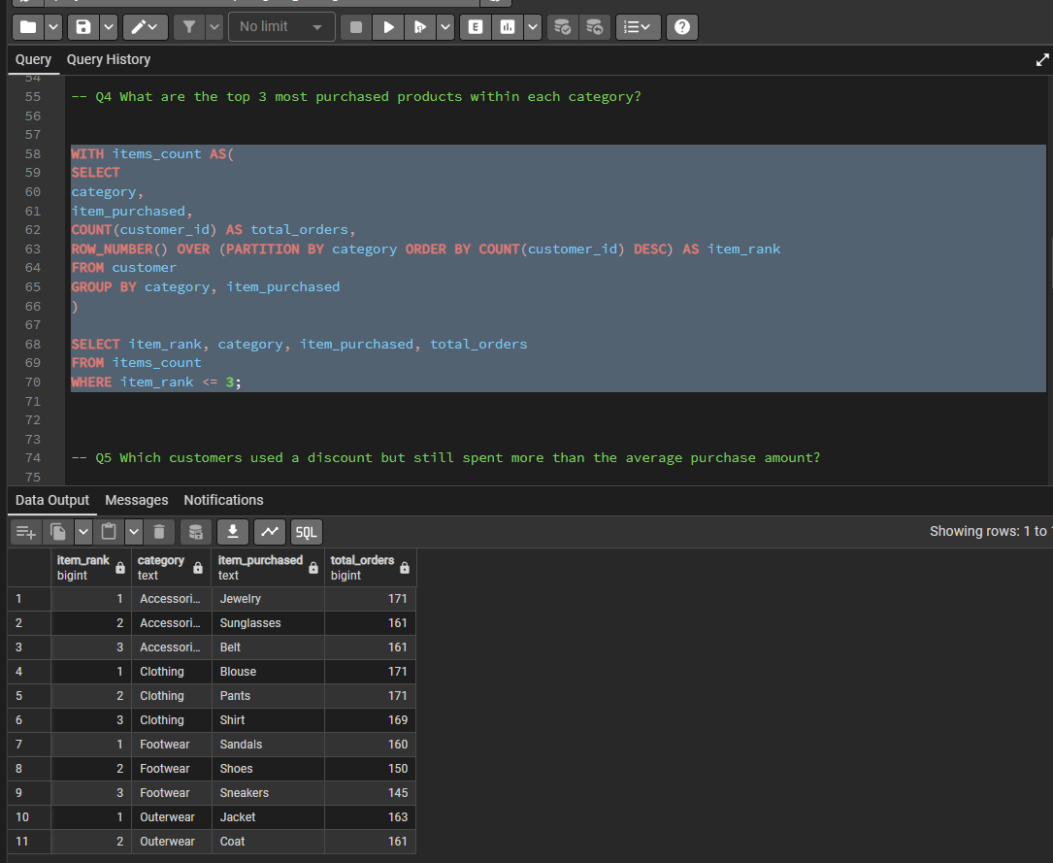
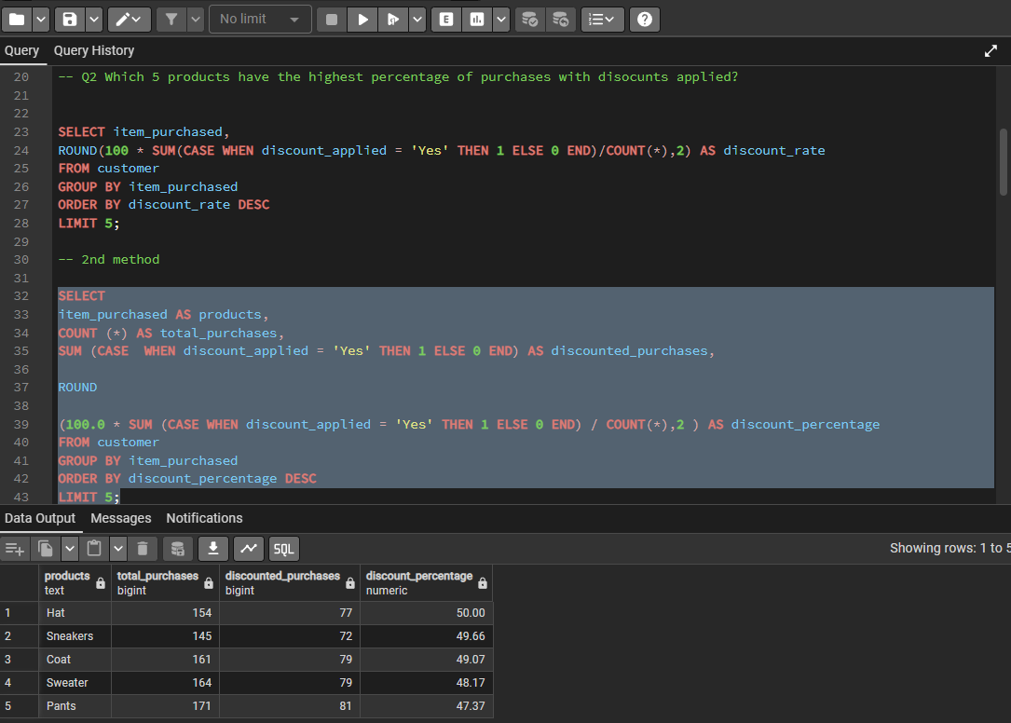
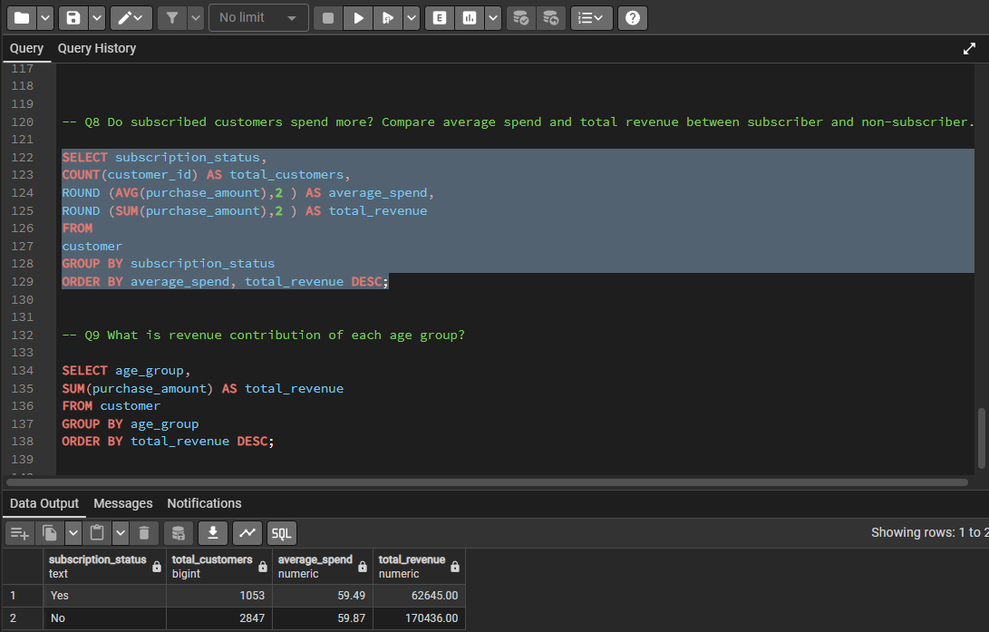

8. Power BI Dashboard
An interactive dashboard was developed in Power BI to visualize customer shopping insights. The dashboard includes KPI cards, seasonal revenue charts, customer demographics, payment methods, subscription analysis, and product category performance.
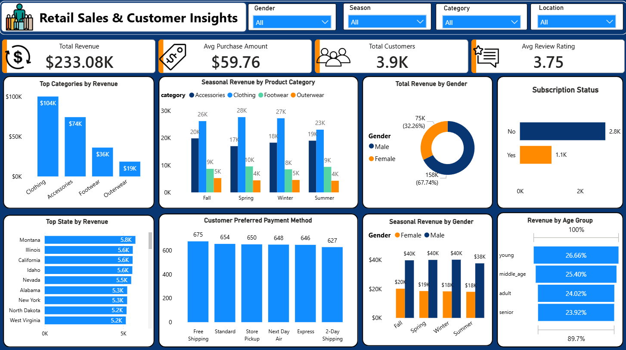

9. Key Business Insights
- Clothing category generated the highest revenue among all categories.
- Male customers contributed a larger share of total revenue.
- Seasonal purchasing patterns showed strong sales during specific periods.
- Subscription-based customers showed noticeable purchasing behavior differences.
- Different payment methods were preferred almost equally by customers.

10. Conclusion
This project successfully demonstrated an end-to-end data analytics workflow, beginning with raw data cleaning and ending with business intelligence dashboard creation. The integration of Python, SQL, PostgreSQL, and Power BI helped generate meaningful business insights and provided hands-on experience with modern analytics tools.

